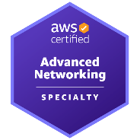
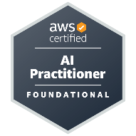
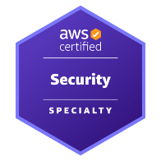
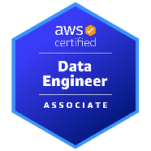
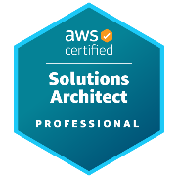
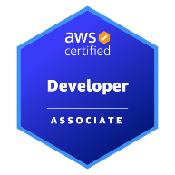
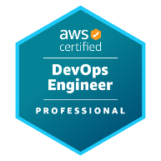
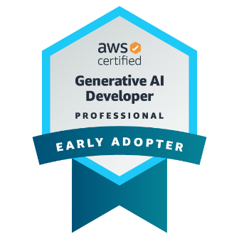


Imma be honest…
I never know exactly what an organization is looking for when they put out a job requisition like yours, but I do humbly believe that I might be that one applicant who does more than just check the boxes on a technical skills matrix.
So who am I?
I’m a technology leader in Agentic AI, AI-enabled software delivery, and enterprise cloud transformation, with 20+ years of experience helping organizations build, modernize, and scale software across healthcare, finance, banking, manufacturing, energy, and professional services.
Over the past several years, I’ve led the adoption of Agentic AI, GitHub Copilot, Microsoft Copilot Studio, Cursor AI, and modern AWS-based AI architectures, while also guiding Agile teams through the real-world delivery of enterprise-grade AI applications from concept to production.
What makes me valuable is the combination of hands-on engineering depth, architecture leadership, Agile delivery experience, and practical AI adoption expertise. I can shape the strategy, write the code, guide the team, explain the business value, and help organizations safely deploy Generative and Agentic AI systems using AWS, Amazon Bedrock, SageMaker, AgentCore, RAG, Python, FastAPI, Java, Spring Boot, Kubernetes, DevOps automation, and secure cloud architecture.
I also hold every active AWS certification, including the latest Agentic AI, Machine Learning, and DevOps Professional exams, giving me a rare blend of verified cloud expertise and hands-on enterprise AI delivery experience.
I would be excited to bring that mix of AI leadership, cloud architecture, Agile execution, and production engineering experience to your organization.
Please take a look at my resume and see if this two-page overview of my 20+ year career piques your interest. If it does, I’d love to speak with you and talk about how I could contribute to your organization.
Sincerely,
Cameron McKenzie

Cameron McKenzie
Responsible Leadership in the Age of Generative and Agentic AI

While I’ve worn many hats over the past 20 years, I always think of myself as a developer at heart. I love technology, I love solving tough problems, and I love that rush that comes when a vision comes to fruition.
I’m also a communicator, team builder, teacher and GitHub Copilot advocate who has spent the past few years building life-changing, Generative and Agentic AI solutions in the AWS cloud. A “Golden Jacket” holder with all 12 AWS certifications, I’m here to help with all of your software architecture, DevSecOps, Agentic AI and application delivery needs.
UDEMY COURSES
I currently have over 35 AWS, GCP, Azure and Java courses on Udemy.

Full-Stack GitHub Copilot in JS & Python
GCP Generative AI Leader Masterclass
AWS Solutions Architect Professional Prep
Spring AI Masterclass for IntelliJ Developers
Official ISACA CISA Exam Prep Course
Azure Developer Certification Prep
Docker & Kubernetes KCNA Exam Prep
ISC2 System Security Practice Exam (SSCP)
Azure Data Scientist Practice Tests
AWS DevOps Professional Exam Course
Pass the Jira Cloud Projects Certification
Official ISACA CISM Exam Prep Course
AWS Machine Learning (Sagemaker) Prep
GitHub Copilot Masterclass for Java & Spring

EDUCATION
Bachelor of Science - Chemistry
Western University
Information Systems Diploma
Durham College
SOCIALS
YouTube - >35,000 Subscribers
youtube.com/@cameronmcnz
LinkedIn
www.linkedin.com/in/cameronwmckenzie
Phone
(407) 214-1352
Email
agentic@mcnz.com
Address
Austin, TX

